- INTRODUCTION

An e-Mail client is an email program; software designed to collect and send electronic mail. It is also referred to as an email program, or mail user agent (MUA) . The term “mail user agent” is less familiar to the average person, but is used in email headers. The headers of the email supply information to the mail servers or computers that handle transferring messages across networks like the Internet.
Networking standards have been established to make exchange of messages possible from a virtual unlimited pool of clients. To this end every mail user agent handles text messages, graphics and attached messages in a similar manner. When a user sends an email an array of information is sent with the message to ensure it reaches its destination. This extra “addressing” information is included in the headers, along with the name of the email program as the “mail user agent.”
Email sent from an Internet Service Provider (ISP) is handled by that ISPs mail server, which is the equivalent of an electronic post office. The mail comes first to the mail server, is processed, and forwarded towards the destination. Anther mail server resides at the destination. It receives all incoming mail and electronically sorts it into mailboxes. The recipient picks up email by using his or her email program to connect to the mail server which request items from the mailbox.
` This project develops a similar e-mail client application using Java and some Java APIs. We use standard sockets and networking and with them additional Java Mail API. The protocols used here are SMTP, POP3. The POP3 is used to receive the mails which has been send to our address.
1.1 Existing system

- In former to Mail client there exists a system called Mail through browser

- We need to use mail services like Yahoo, Google, and Hotmail.

- They use HTTP port 80 to access the mails.

1.1.1 Limitations of the existing system:

- The browsers are not safe to send confidential messages.

- Some companies create own mail services to send mails.

- They can be easily hacked by hackers.

- The valuable data is modified and it may be lost

1.2 Proposed System

- The email client is a java based program.
- It can be used by running the java code.
- It is used to send mails and receive mails securely.
- Cost of mail client is less when compared to mail services,
2.REQUIREMENT ANALAYSIS

2.1 Hardware And Software Specifications

2.1.1 Hardware:-

- No of Systems: 2 - Client & Server (Minimum)

- Processor: Intel P4 (Or equivalent)

- Hard Disk : 40 GB

- RAM: 512 MB (minimum)

Network: Standard Wired/Wireless network with either Ad-hoc or infrastructure mode

2.1.2 Software:-
- Operating System: Windows, Linux
- Software’s: Java SDK 2, Borland Net-Beans 6.0
2.2 System Design:
2.2.1MailClient:
2.2.1.1What is an email client?
In most cases, your email account exists on a central server, and not on your personal computer or workstation. An email client is software that allows you to read and send email through your account by connecting to this server. Email clients generally provide a simple interface through which you can access your email account.
Many email clients are available. Some in common use at Indiana University include IU Webmail, Thunderbird, Eudora, Mac OS X Mail, Outlook Express, Entourage, Outlook,andOutlookWebAccess.
2.2.1.2General sending and receiving mails:
- Client1 writes email
- Client1 sends email(Click send), the email is delivered to SMTP server1
- SMTP server1 looks up the domain ,and finds out that SMTP server2 is the correct server.
- SMTP server 1sends the email to SMTP server2
- SMTP server 2 receives the email, and put it up in drop folder (windows SMTP)
- This is how far wou get without a POP3 server (or IMAP)
- With a POP3 server, the POP3 server checks the drop folder for emails, then move it to the orrect mailbox
- Client pc2(User 2) connects to the POP3 server, to download email, and POP3 server "POP"uot the email to the client pc2
- Client2 reads the email sent by the client1
. It outlines basic steps involved in sending an email message 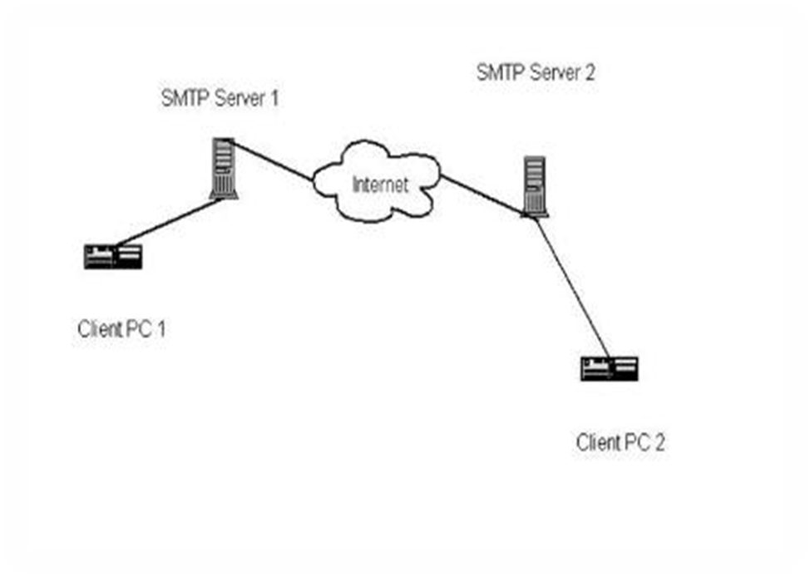
Fig2.1
2.3 Software Requirement Specification
Software Requirements Specification is the starting point of Software development activity. It is the most difficulty activity and the most error prone Software Requirements Specification is a means of translating the ideas in the minds of clients into one formal document.

This document is used for the Software Project Management. In the organization the Admin, Project Manager, Project Leader, and Developer the uses the system for different purposes like Employee Details, Employee performance, Client Details, Project status, Module status, report generations etc.

2.3.1. Introduction:-

SRS plays an important role in the designing a project. SRS meets the needs for project designing and developing. The entire information which is needed for the project is specified in this SRS.
SRS contains the feasibility concepts of the projects software, hardware requirements, duration of the project, cost effort of the project etc comes under SRS.
SRS goes as an input to design phase for the project. First we have to know the detailed structure of the project which is nothing but SRS, which tells us the project or task then proceed to design phase. Based on the feasibility study the SRS is prepared as below.

2.3.1.1Purpose:-
The purpose of this document is to describe all the external requirements for a organization. It also describes the interfaces for the system.

2.3.1.2 Scope:-
This document describes about the requirements of the banking system. It will be used by the developers and will be the basis of validating the final delivered system. Any changes made to the requirements in the future will have to go through a formal change approval process. The developer is responsible for clarifications where necessary and will not make any alterations without the permission of the client.
2.3.1.3 References:-
Existing Manual Software Project Management
2.3.1.4 Developers responsibilities overview:-
The developer is responsible for
- Developing the system
- Installing the software on the client’ s hardware
- For conducting any user training that might be needed for using the system.
- Maintaining the system for a period of time after installation.

2.3.2 General Description:-
2.3.2.1 User Characteristics:-
The main users of the system will be Admin, Project Leader, Project Manager, and Developer, who are literate about computers and can use programs

2.3.3 Functional Description
2.3.3.1 General description of Inputs and Outputs:-
The system has 3inputs and produces 1 major outputs. The general description of these are as follows.

2.3.4 External Interface Requirements:-

2.3.4.1 User Interface:-
The main user of the organization is Admin. The user interface is a GUI window where the command names reflect the function they perform.
2.3.4.2 Hardware Interface:-
This project should be run on Pentium and 512 RAM should be used.

2.3.4.3 Software Interface:-
Windows XP or Windows NT operating system should be used.

2.3. 5 Performance Requirements:-

2.3.5.1 Static Requirements:-
These are the requirements that are essential for the better performance of the system before the system gets executed. These include the number of computers to be supported, the number of files and their sizes the system has to process. The server side computers should be highly configured with a memory capacity to store all the class files and the database. Client side computers should be appropriately configured.
2.3.5.2 Dynamic Requirements:-
A high capacity RAM and high frequency processor will enable the System to perform services fastly and efficiently.

2.4 Feasibility Study

Feasibility study is an important phase in the software development process. It enables the developer to have an assessment of the product being developed. It refers to the feasibility study of the product in terms of the product, operational use and technical support required for implementing it.
Feasibility study should be performed on the basis of various criteria and parameters. The various feasibility studies are:
- Economic Feasibility
- Operational Feasibility
- Technical Feasibility

2.4.1 Economic Feasibility:
It refers to the benefits or outcomes we are deriving from the
product as compared to the total cost we are spending for developing the product. If the benefits are more or less the same as older system, then it is not feasible to develop product.

2.4.2 Operational Feasibility:
It refers to the feasibility of the product to be operational. Some
Products may work very well at design and implementation but may fail in the real time environment. It includes the study of additional human resource required and their technical expertise.

2.4.3 Technical Feasibility:
It refers to whether the software that is available in the market fully supports the present application. It studies the pros and cons of using particular software for the development and its feasibility. It also studies the additional training needed to be given to the people to make the application work.
3. DESIGN ANALYSIS
3.1Unified Modeling Language Diagrams
The unified modeling language allows the software engineer to express an analysis model using the modeling notation that is governed by a set of syntactic semantic and pragmatic rules.
A UML system is represented using five different views that describe the system from distinctly different perspective. Each view is defined by a set of diagram, which is as follows.
3.1.1 User Model View
- This view represents the system from the users perspective.
- The analysis representation describes a usage scenario from the end-users perspective.

3.1.2 Structural model view
- In this model the data and functionality are arrived from inside the system.
- This model view models the static structures.
3.1.3 Behavioral Model View
It represents the dynamic of behavioral as parts of the system, depicting the interactions of collection between various structural elements described in the user model and structural model view.
    - Implementation Model View
In this the structural and behavioral as parts of the system are represented as they are to be built.

3.1.5 Environmental Model View
- In this the structural and behavioral aspects of the environment in which the system is to be implemented are represented.
- UML is specifically constructed through two different domains they are
- UML Analysis modeling, which focuses on the user model and structural model views of the system
- UML design modeling, which focuses on the behavioral modeling, implementation modeling and environmental model views.

3.2 Use Case Diagrams
The actors identified upon the System are as follows.
- Receiver

Name
Password
Smtp Server
POP3 Server


Receiver

Fig 3.1
Class Diagrams:
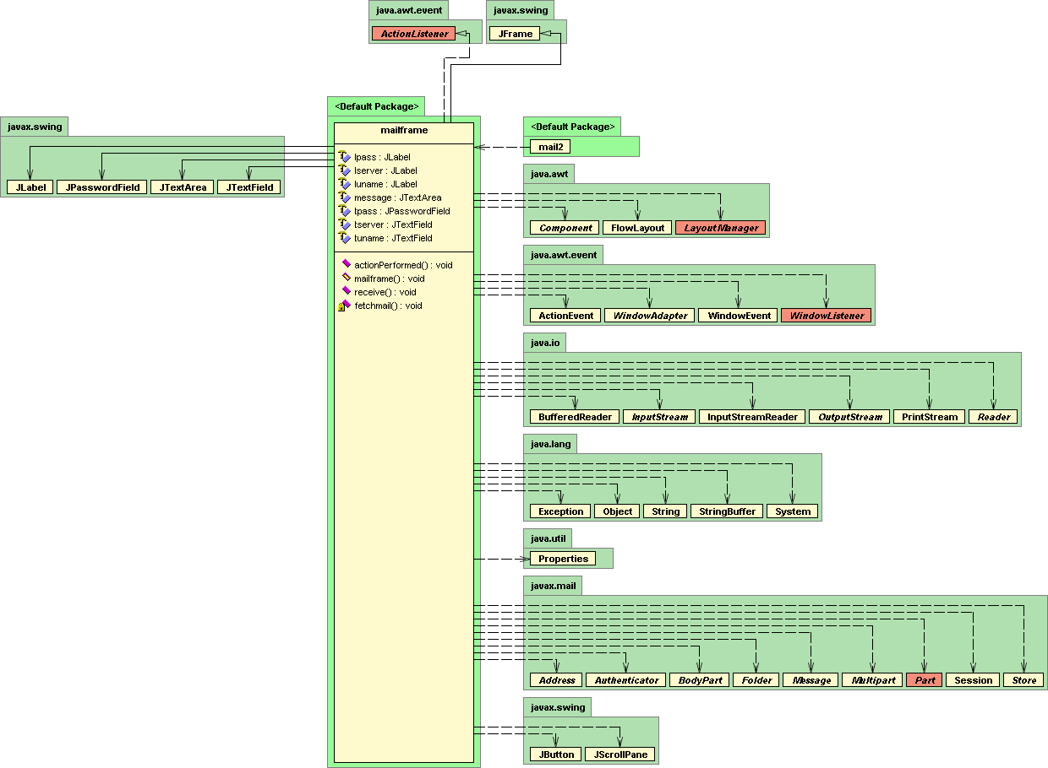

Fig 3.2
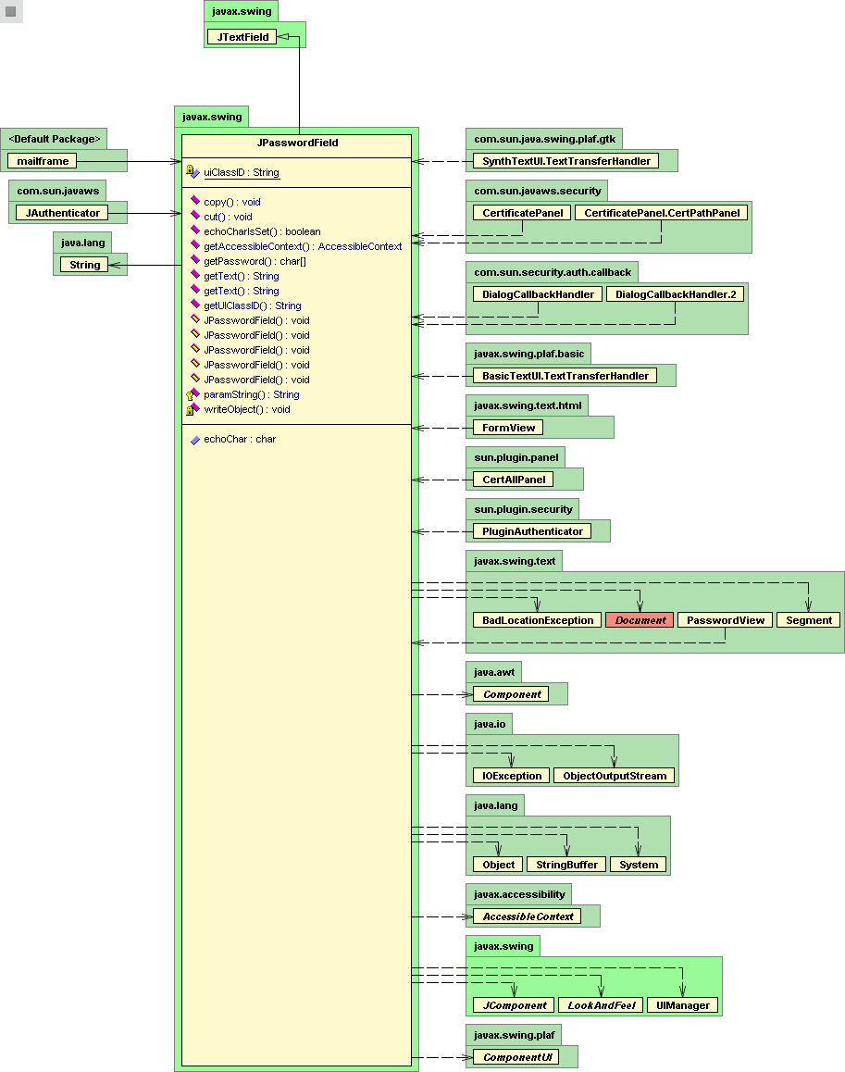

Fig 3.3
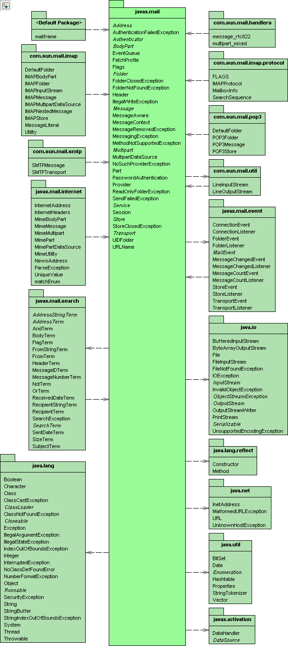

Fig 3.4

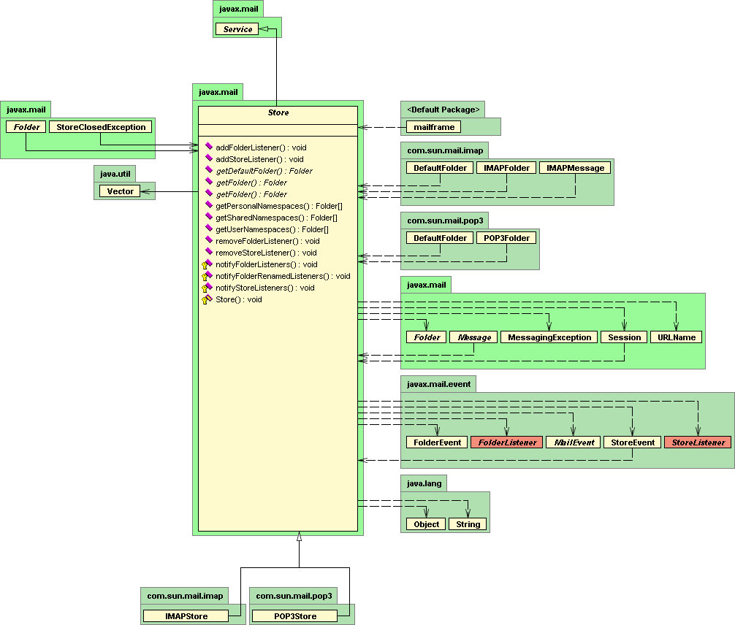

Fig 3.5
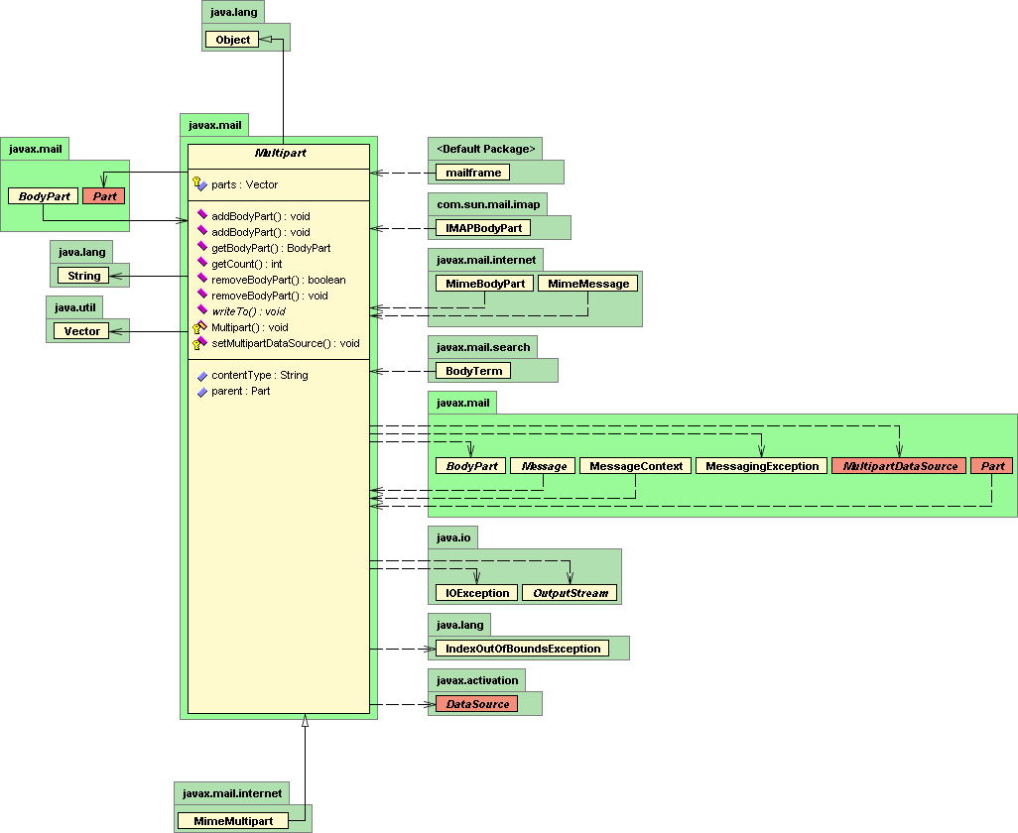

Fig 3.6
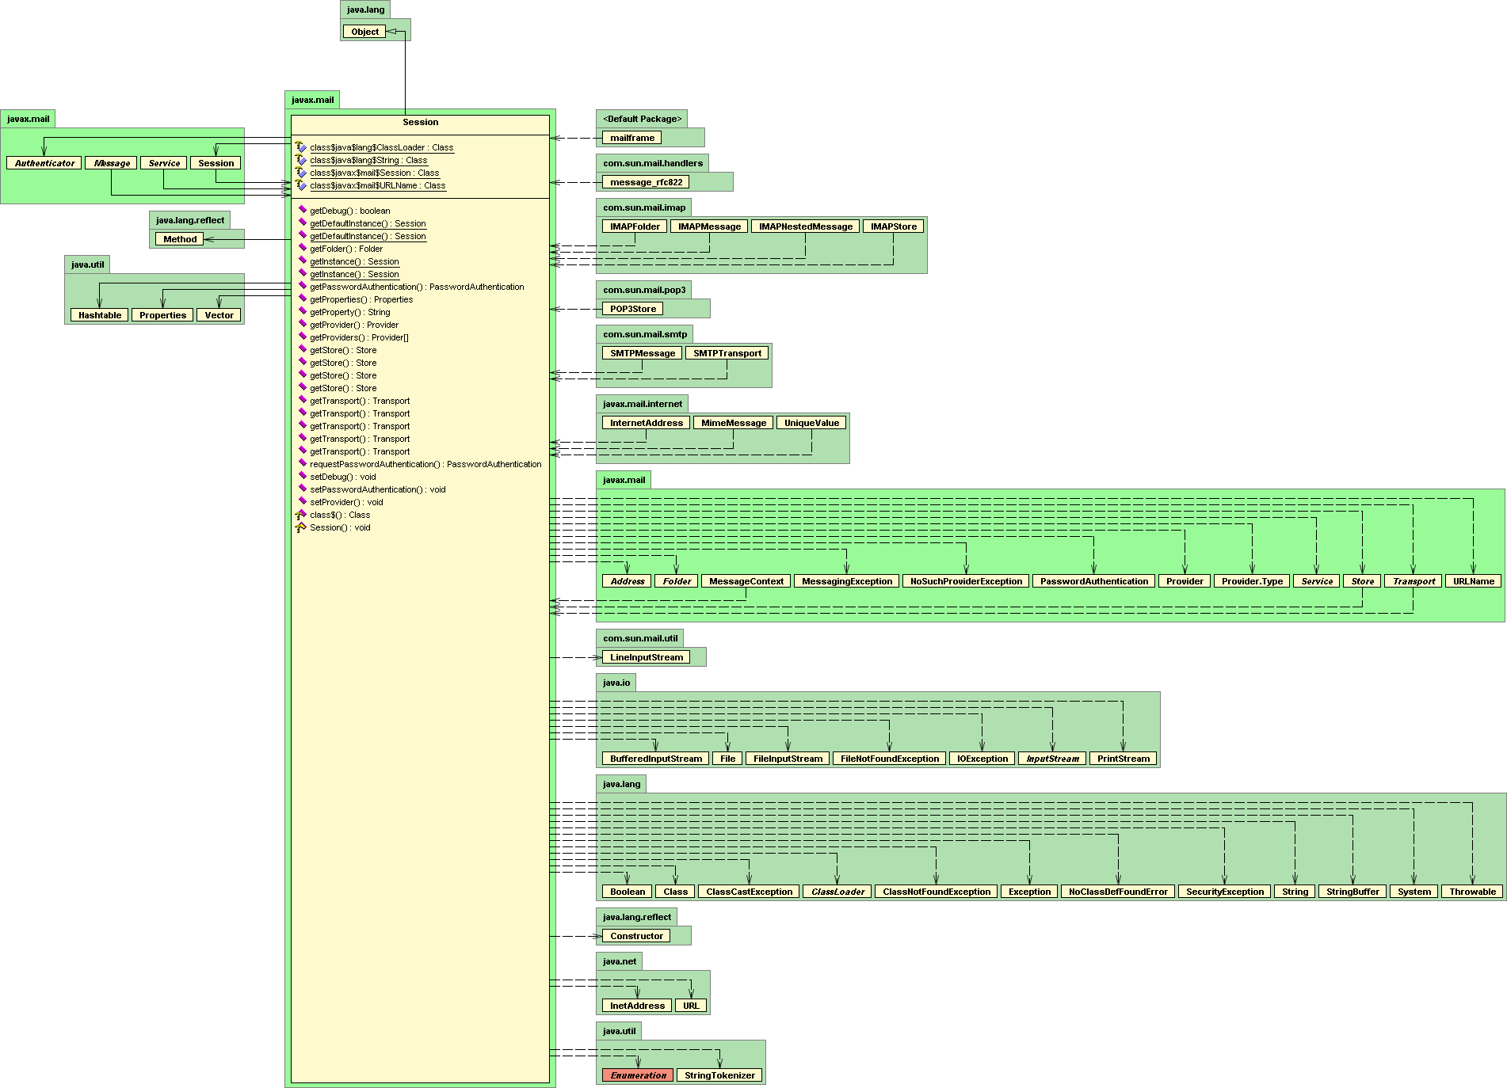

Fig 3.7
4.SYSTEM IMPLEMENTATION

4.1 Selected Software

4.1.1 About JAVA:

Java is a programming language originally developed by James Gosling at Sun Microsystems and released in 1995 as a core component of Sun Microsystems' Java platform. The language derives much of its syntax from C and C++ but has a simpler object model and fewer low-level facilities. Java applications are typically compiled to bytecode (class file) that can run on any Java virtual machine (JVM) regardless of computer architecture.

4.1.1.1 History of JAVA:

James Gosling initiated the Java language project in June 1991 for use in one of his many set-top box projects.[5] The language, initially called Oak after an oak tree that stood outside Gosling's office, also went by the name Green and ended up later renamed as Java
Sun released the first public implementation as Java 1.0 in 1995. It promised "Write Once, Run Anywhere" (WORA), providing no-cost run-times on POPular platforms. Fairly secure and featuring configurable security, it allowed network- and file-access restrictions
On 13 November 2006, Sun released much of Java as free and open source software under the terms of the GNU General Public License (GPL). On 8 May 2007 Sun finished the process, making all of Java's core code available under free software / open-source distribution terms, aside from a small portion of code to which Sun did not hold the copyright.

4.1.1.2 Features of JAVA:
4.1.1.2.1 Portability:
- Computer programs written in the Java language must run similarly on any supported hardware/operating-system platform.
- One should be able to write a program once, compile it once, and run it anywhere.It is achieved by compiling the Java language code, not to machine code but to Java bytecode – instructions analogous to machine code but intended to be interpreted by a virtual machine (VM) written specifically for the host hardware.
- End-users commonly use a Java Runtime Environment (JRE) installed on their own machine for standalone Java applications
- In some JVM versions, bytecode can be compiled to native code, either before or during program execution, resulting in faster execution.
4.1.2 Java Mail:
Java Mail is a Java API used to receive and send email via SMTP,POP3 and IMAP. Java Mail is built into the Java EE platform, but also provides an optional package for use in Java SE
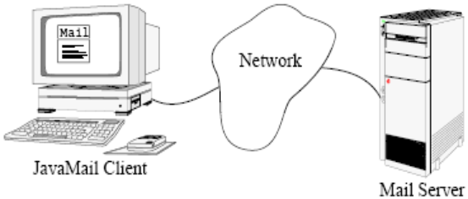
Fig 4.1
4.1.2.1 Introducing Java Mail:
The Java Mail API defines classes such as Message, Store, and Transport. The API can be extended and can be subclassed to provide new protocols and to add functionality when necessary. In addition, the API provides concrete subclasses of the abstract classes. These subclasses, including MimeMessage and MimeBodyPart, implement widely used Internet mail protocols and conform to the RFC822 and RFC2045 specifications. The Java Mail API includes support for the IMAP4, POP3, and SMTP protocols.

4.1.2.2 The Java Mail architectural components are as follows:
The abstract layer declares classes, interfaces, and abstract methods intended to support mail handling functions that all mail systems support.
The internet implementation layer implements part of the abstract layer using the RFC822 and MIME internet standards.
Java Mail uses the JavaBeans Activation Framework (JAF) to encapsulate message data and to handle commands intended to interact with that data
4.1.2.3 Creating a Java Mail Session
You can create a Java Mail session in the following ways:
In the Administration Console, open the Resources component and select Java Mail Sessions.
Use the asadmin create-Java Mail-resource command.

4.1.2.4Java Mail Session Properties
You can set properties for a Java Mail Session object. Every property name must start with a mail- prefix. The Application Server changes the dash (-) character to a period (.) in the name of the property and saves the property to the MailConfiguration and Java Mail Session objects. If the name of the property doesn’t start with mail-, the property is ignored.
For example, if you want to define the property mail.from in a Java Mail Session object, first define the property as follows:
* Name - mail-from
* Value - john.doe@sun.com
After you get the Java Mail Session object, you can get the mail.from property to retrieve the value as follows:
String password = session.getProperty("mail.from");
4..1.3 The Java Mail API :
One of the most frequently asked questions about Java is how to send email from a Java applet or application. While it's certainly possible to write a Java program that uses sockets to communicate with mail servers, this requires detailed knowledge of some fairly complicated protocols, such as SMTP, POP, and IMAP.
The Java Mail API is a standard extension to Java that provides a class library for email clients. It's a required component of the Java 2 Platform, Enterprise Edition (J2EE). The Java Mail API can be implemented in 100% Pure Java™ using sockets and streams, and indeed Sun's reference implementation is so implemented. Programs use the Java Mail API to communicate with SMTP, POP, and IMAP servers to send and receive email. Additional providers can add support for other mail systems such as Hotmail or MH..
Most obviously, you can write standard email clients such as Eudora. But the Java Mail API is also useful as a part of larger applications that simply need to send or receive a little email. For instance, a server-monitoring application such as Whistle Blower can periodically load pages from a web server running on a different host and email the webmaster if the web server has crashed. An applet can use email to send data to any process or person on the Internet that has an email address, in essence using the web server's SMTP server as a simple proxy to bypass the usual security restrictions about whom an applet is allowed to talk to. In reverse, an applet can talk to an IMAP server on the applet host to receive data from many hosts around the Net. A newsreader could be implemented as a custom service provider that treats NNTP as just one more means of exchanging messages. And that's just the beginning of the sort of programs the Java Mail API makes it very straightforward to write. 4.1.3.1 What Is the Java Mail API?
- The Java Mail API is a fairly high-level representation of the basic components of any email system. The components are represented by abstract classes in the javax.mail package. For instance, the abstract class javax.mail.Message represents an email message. It declares abstract methods to get and set various kinds of envelope information for the message, such as the sender and addressee, the date sent, and the subject of the message. The abstract class javax.mail.Folder represents a message container. It declares abstract methods to get messages from a folder, move messages between folders, and delete messages from a folder.
- These classes are all abstract because they don't make many assumptions about how the email is stored or transferred between machines. For instance, they do not assume that messages are sent using SMTP or that they're structured as specified in RFC 822. Concrete subclasses of these classes specialize the abstract classes to particular protocols and mail formats. If you want to work with standard Internet email, you might use javax.mail.MimeMessage instead of javax.mail.Message, javax.mail.InternetAddress instead of javax.mail.Address, and com.sun.mail.imap.IMAPStore instead of javax.mail.Store. If you were writing code for a Lotus Notes-based system, you'd use different concrete implementation classes but the same abstract base classes.
- Since mail arrives from the network at unpredictable times, the Java Mail API relies on an event-based callback mechanism to handle incoming mail. This is exactly the same pattern (even using some of the same classes) found in the AWT and JavaBeans. The javax.mail.event package defines about half a dozen different kinds of mail events, as well as the associated listener interfaces and adapter classes for these events.
- Sun's implementation includes POP3, SMTP, and IMAP providers. However, third parties have written providers for other protocols such as Hotmail, NNTP, Exchange, and more.
.
4.1.3.2 Looking Up a Java Mail Session
The resource lookup in the application code looks like this:
Initial Context ic = new Initial Context();
String snName = "java: comp/env/mail/MyMailSession";
Session session = (Session)ic.lookup(snName);
4.2 Protocols Used
4.2.1 SOCKET:
A software object that connects an application to a network protocol. In Java, a program can send and receive TCP/IP messages by opening a socket and reading and writing data to and from the socket.
4.2.1.1Types of Sockets:
There are several Internet socket types:
- Datagram sockets, also known as connectionless sockets, which use User Datagram Protocol (UDP).
- Stream sockets, also known as connection-oriented sockets, which use Transmission Control. Protocol (TCP) or Stream Control Transmission Protocol (SCTP).
- Raw sockets (or Raw IP sockets), typically available in routers and other network equipment.
4.2.2 PORTS:
In computer networking, a port is an application-specific or process-specific software construct serving as a communications endpoint used by Transport Layer protocols of the Internet Protocol Suite such as Transmission Control Protocol (TCP) and User Datagram Protocol (UDP).
4.2.2.1 Port number:
A specific port is identified by its number, commonly known as the port number, the IP address it is associated with, and the protocol used for communication.
A port number is a 16-bit unsigned integer, thus ranging from 0 to 65535. A process associates with a particular port (known as binding) to send and receive data, meaning that it will listen for incoming packets whose destination port number and IP destination address match that port, and/or send outgoing packets whose source port number is set to that port. Processes may bind to multiple ports.
Port number 21 is for FTP,
23 is for Telnet,
25 is for e-mail,
79 is for finger,
80 is for HTTP,
119 is for netnews—and the list goes on.
4.2.2.2 Range of Port Numbers:
The port numbers are divided into three ranges: the Well Known Ports, the Registered Ports, and the Dynamic or Private Ports.
- The Well Known Ports are those from 0 through 1023.
- The Registered Ports are those from 1024 through 49151.
- The dynamic or Private Ports are those from 49152 to 65535.
- Email servers and client use the following TCP port numbers by default, unless configured for specialized installations:
- protocol use plain text or encrypt sessions plain text sessions only encrypt sessions only
- POP3 incoming mail 110 995
- IMAP4 incoming mail 143 993
- SMTP outgoing mail 25 (unofficial) 465
- MSA outgoing mail 587
4.3 INET ADDRESS
- Whether you are making a phone call, sending mail, or establishing a connection across the Internet, addresses are fundamental.
- The InetAddress class is used to encapsulate both the numerical IP address we discussed earlier and the domain name for that address.
- You interact with this class by using the name of an IP host, which is more convenient and understandable than its IP address.
- The InetAddress class hides the number inside. As of Java 2, version 1.4, InetAddress can handle both IPv4 and IPv6 addresses. This discussion assumes IPv4.

4.4 SMTP
Simple Mail Transfer Protocol (SMTP) is an Internet standard for electronic mail (e-mail) transmission across Internet Protocol (IP) networks. SMTP was first defined in RFC 821 (STD 15),[1] and last updated by RFC 5321 (2008)[2] which includes the extended SMTP (ESMTP) additions, and is the protocol in widespread use today.While electronic mail servers and other mail transfer agents use SMTP to send and receive mail messages, user-level client mail applications typically only use SMTP for sending messages to a mail server for relaying.
SMTP is a relatively simple, text based protocol, in which a mail sender communicates with a mail receiver by issuing simple command strings and supplying necessary data over a reliable ordered data stream channel, typically a Transmission Control Protocol (TCP) connection
4.5 POP3
Post Office Protocol (POP) is an application-layer Internet standard protocol used by local e-mail clients to retrieve e-mail from a remote server over a TCP/IP connection. POP and IMAP (Internet Message Access Protocol) are the two most prevalent Internet standard protocols for e-mail retrieval. Virtually all modern e-mail clients and servers support both. The POP protocol has been developed through several versions, with version 3 (POP3) being the current standard.
The design of POP and its procedures supports end-users with temporary Internet connections, such as dial-up access, allowing these users to retrieve e-mail when connected and then to view and manipulate the retrieved messages when offline. Although most clients have an option to leave mail on server, e-mail clients using POP generally connect, retrieve all messages, store them on the user's PC as new messages, delete them from the server, and then disconnect.
Clients with a leave mail on server option generally use the POP3 UIDL (Unique IDentification Listing) command. Most POP3 commands identify specific messages by their ordinal number on the mail server. This creates a problem for a client intending to leave messages on the server, since these message numbers may change from one connection to the server to another.
4.6 Data Base used (Mail Store):
Here in our Mail Client Mail Store is worked as the database . Mail Store is fixed in fixed in both the SMTP server.Mail Store stores the all the details of sender and receiver i.e Sender address, Receiver address, Subject, Time, Date , IP address, signature, Message body
4.7 OVERVIEW OF THE MAIL CLIENT
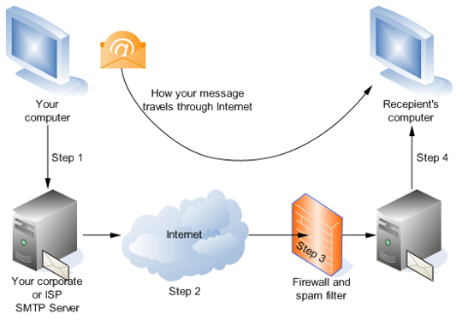
Fig4.2
4.8 Sample Coding:
public class mail2 extends JFrame
{
Static String POPServer;
Static String POPUser;
Static String POPs Password;
Public static void main(String args[])
{
//POPServer=args [0];
//POP User=args [1];
//POPPassword=args [2];
JFrame frame = new mailframe ();
frame.setVisible (true);
}
}

@SuppressWarnings ("serial")
Class mail frame extends JFrame implements ActionListener
{
JLabel lserver =new JLabel ("SMTP Server");
Static JTextField tserver = new JTextField (15);
JLabel luname =new JLabel ("UserName");
Static JTextField tuname = new JTextField (15);
JLabel lpass =new JLabel("Password");
Static JPasswordField tpass = new JPasswordField(15);
Static JTextArea message = new JTextArea(30,72);

Public mailframe()
{
this.setSize(850,500);
this.setLayout(new FlowLayout(FlowLayout.LEFT));

addWindowListener(new WindowAdapter()
{
public void windowClosing(WindowEvent e)
{
System.exit(0);
}
}
);

tpass.setEchoChar('*');
this.add(lserver);
this.add(tserver);
this.add(luname);
this.add(tuname);
this.add(lpass);
this.add(tpass);

JButton b1 =new JButton("Fetch");
b1.addActionListener(this);
this.add(b1);

message.setEditable(false);
JScrollPane sp = new JScrollPane();
message.add(sp);
this.add(message);

}
public void actionPerformed(ActionEvent e)
{
System.out.println("debug button");
fetchmail();
}
@SuppressWarnings("deprecation")
private void fetchmail()
{
String POPServer;
String POPUser;
String POPPassword;

POPServer = mailframe.tserver.getText();
POPUser = mailframe.tuname.getText();
POPPassword = mailframe.tpass.getText();

System.out.println(POPServer);
try
{
receive(POPServer, POPUser, POPPassword);
//receive("mail.imparttechnologies.com","testproject@imparttechnologies.com", "password123");
}
catch (Exception ex)
{
System.out.println("Usage: java jmail"+" SMTPServer address password ");
}
//System.exit(0);
}
5. TEST CASES

5.1 Testing:

Testing is the process of finding differences between the expected behavior specified by system models and the observed behavior of the system. During testing, the program to the tested is executed with a set of test cases, and the output of the program for the test cases is evaluated to determine if the program is performing as it is expected to. When differences are found, developers identify the defect causing the observed failure and modify the system to correct it. In other cases, the system model is identified as cause of the difference and model updated to reflect the state of the system.

5.1.1 Need for testing:
The goal of testing is to design tests that exercise defects in the system and to reveal problems. Testing is a fault detection technique that tries to create failures or errors in a planned way. This allows a developer to detect failure in the system before it is released to the customer. The characteristics of a good test model are that it contains test cases that identify errors. Every input that can possibly be given to the system to be tested. Otherwise, there is a chance that falls are not detected.

5.1.2 Software Testing:
In any software development, testing is a process to show the correctness of the program and it meets the design specification. Testing is needed to prove correctness, to show completeness, to improve the quality of the software and to provide the maintenance aid. Some testing standards are therefore necessary to ensure completeness of testing, improve the quality of the software, and reduce the testing costs and to reduce study needs and operation time.

5.1.3 Goals of Testing:
The following are the goals of testing
- Testing is a process of executing a program with the intent of finding an error.
- A good test case is the one that has a high probability of finding as an yet undiscovered error.
- A successful test is one that uncovers an as yet undiscovered error.

5.2 Testing Methods:

5.2.1 Top-Down Testing
Top-Down Testing tests the higher levels of a system before testing its detailed components. The program is represented as a single abstract component with sub components represented by stubs. Stubs have the same interface as the components but very limits functionality. After the top-level component has been tested, its sub-components are implemented and tested in the same way. This process continues recursively until the bottom-level components are implemented. The whole system may then be completely tested.

5.2.2 Bottom-Up Testing
Bottom-Up Testing is the converse of Top-Down Testing. It involves testing the modules at the lower levels of the hierarchy and then working up the hierarchy of the modules until the final module is tested. When using bottom-up testing test drivers must be written to exercise the lower level components. The test drivers simulate the components environment and are valuable components; the test drivers and test data should be distributed with the component. Potential re-users can then run these tests to satisfy themselves that the component behaves as expected in their environment.

5.2.3 Black Box Testing:
Knowing the specified function that a product has been designed to perform, test can be conducted that demonstrates each function that is fully operational, at the same time searching for errors in each function. Black Box testing focuses on functional requirement of the software. Black Box testing attempts to find out errors in the following categories:

- Incorrect or missing functions.
- Interface errors.
- Errors in data structures or external database access.
- Performance and errors.
- Initialization and termination errors.

5.2.4 White Box Testing:
Knowing the internal working of a product, test can be conducted to ensure that “all gears mesh” that is internal operation performs according to specification and all internal components have been adequately exercised. Using white box testing methods, the software engineer can derive test cases that:

- Guarantee that all independent paths with in a module has been exercised at least once………. Basis path testing
- Exercise all logical decisions on their true and false sides ….. condition testing
- Execute all loops at their boundaries and within their operation bounds… loop testing

5.3 Levels of Testing:
Different levels of testing attempts to detect different types of faults. Basic levels are:
- Unit Testing
- Integration Testing
- Regression Testing
- System Testing

5.3.1 Unit Testing
Unit testing tries to find faults in participating objects and subsystems with respect to the use cases from the useless mode. Different modules are tested against specifications produced during design for the modules. Unit testing is essential for the verification of the code produced during the coding phase and hence the goal is to test the internal logic of the modules i.e. unit testing focuses on individual components. So in our project each and every segment in every module is tested.

5.3.2 Integration Testing
Integration testing detects faults that have not been detected during unit testing, by focusing on small group of components. Two or more components are integrated and tested and once tests do not reveal any new faults, additional components are added to the group. This procedure allows the testing of increasingly more complex parts of the system while keeping the location of the potential faults relatively small. This activity can be considered as testing the design and hence the emphasis is on testing module interactions. So each module in the project is tested to ensure smooth functioning of the module.

5.3.3 Regression Testing
Each time a new module is added as part of integration testing, the software changes. New data paths are established, new I/O may occur, and new control logic is invoked. These changes may cause problems with functions that previously worked flawlessly. In the context of an integration test strategy, regression testing is the rexecution of some subset of tests that have already been conducted to ensure that changes have not propagated unintended side effects. Regression Testing is the activity that helps to ensure that changes do not introduce unintended behavior or additional errors

5.3.4 System Testing
System testing tests all the components together, seen a single system to identify errors with respect to scenarios from the problem statement and the requirements and design goals identified in the analysis and system analysis i.e. during system testing entire software system is tested. The reference document for this process is requirement document and the goal is to see if the software meets its requirements. Several important system-testing activities are

5.3.5 Functional Testing
Test of functional requirements (from RAD) and if available from the user manual.

5.3.6 Performance Testing
Test of non-functional requirements (from RAD) and additional design goals (from SD).

5.3.7 Acceptance Testing
Check the requirements against the project agreement and should be done by the client, if necessary with support by the developers. This testing is performed to demonstrate that software is working as expected.

5.4 TEST PLAN:

The test plan focuses on the managerial aspects of testing. It documents the scope, approach, resources and schedule of testing activities. The requirements and the components to be tested are identified in the document

Mail Client Execution:

Test Plan ID | Input | Description | Expected result
Tp_1 | Server name blank, user name  password blank | No server name, username, Password,  Received by server | Display error
Tp_2 | Valid server name valid user name valid password | Valid server name valid user name password given | Mails displayed
Tp_3 | Invalid server name | Invalid server name is given to server | You should enter valid server name
Tp_4 | Type wrong command | Command is wrong | Display as default

5.5 TEST CASE:

It lists the test cases that are needed for testing. Each test case is described in detail in separate test case specification document. Each execution of these tests will be documented in a test indent report document.

Mail Client Execution:

Test Case ID | Input | Description | Expected result | Pass/Fail
Tc_1 | Server name blank, user name  password blank | No server name, username,Password,  Received by server | Display error | Fail
Tc_2 | Valid server name valid user name valid password | Valid server name valid user name password given | Mails displayed | Pass
Tc_3 | Invalid server name | Invalid server name is given to server | You should enter valid server name | Fail
Tc_4 | Type wrong command | Command is wrong | Display as default | Fail

6. SCREENS & REPORTS

6.1 Screens

6.1 Login:
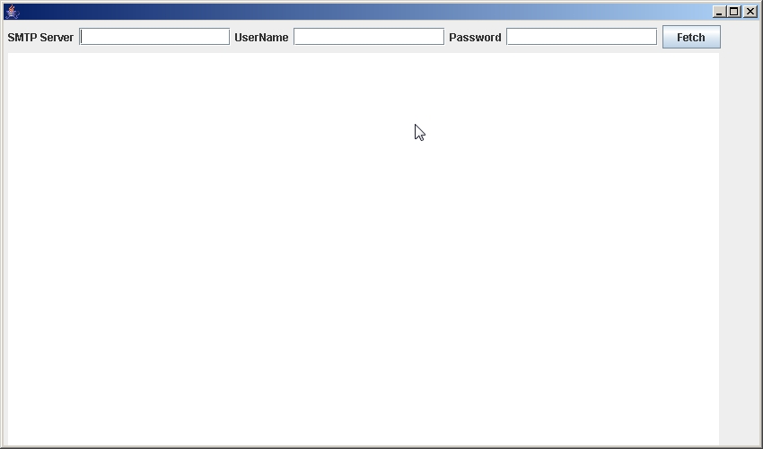
Fig 6.1

6.1.2 Login (after enter details)
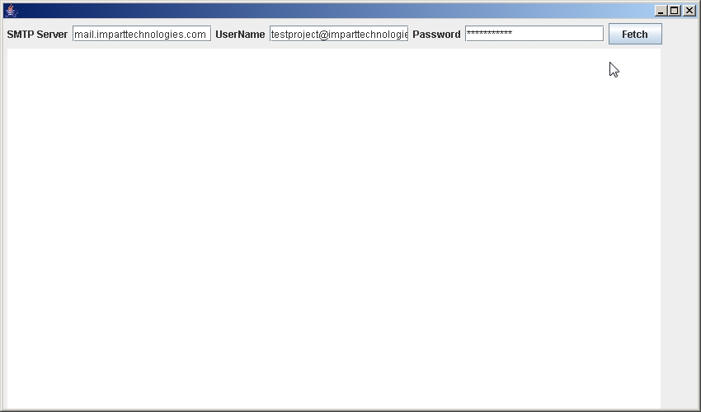

Fig 6.1.2

6.2 Reports

6.2.1 Message Window:
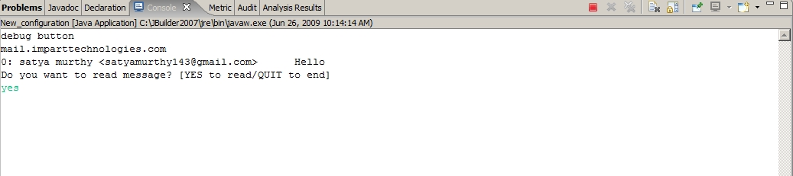

Fig 6.2.1

6.2.2 Message Pattern:
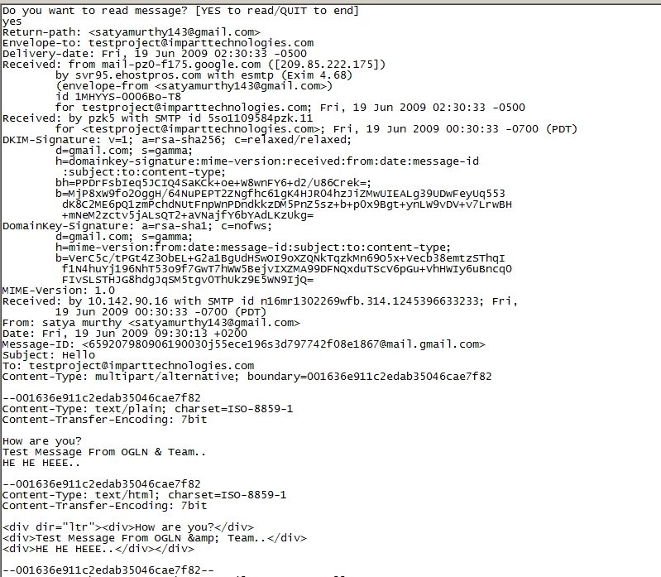

Fig 6.2.2

6.2.3 Messages

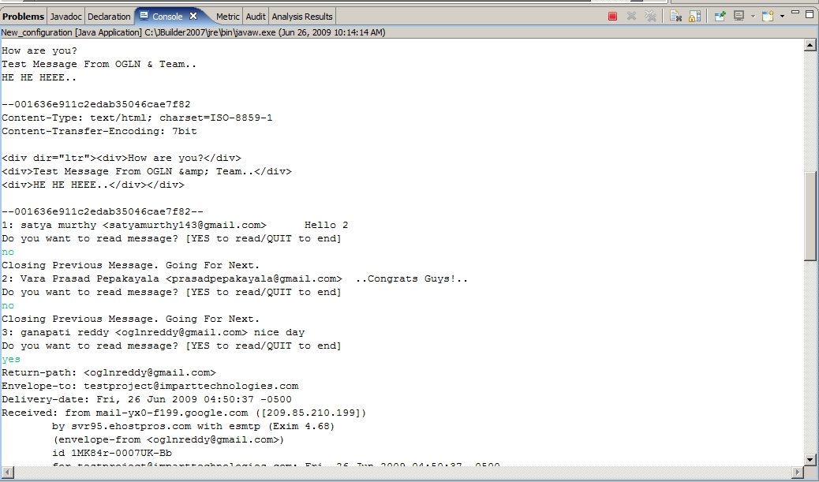
Fig 6.2.3

6.2.4Messages:
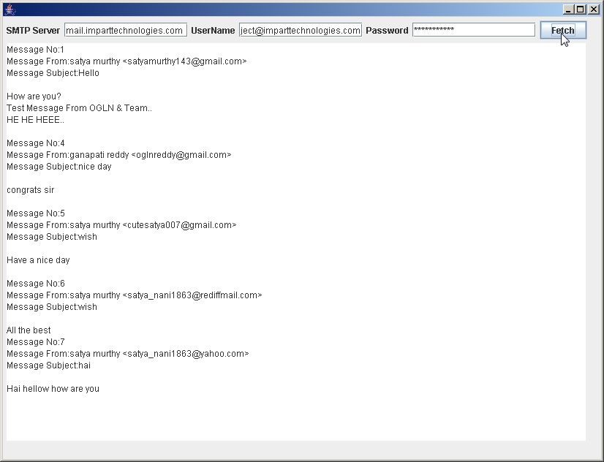
Fig 6.2.4

7. CONCLUSION AND FUTURE SCOPE

7.1 Conclusion:

This system is implemented fulfilling all the client requirements. The interfaces designed for the system is very user friendly and attractive. It has successfully implemented the receive messages as per the client requirement.
The system has successfully passed the testing at the development site and is under the testing phase in the presence of the client. The system is waiting for the client response.

7.2 Future Scope of the Project:

This object is having a broad future scope as it can be extended to provide sending messages on line. This system can be implemented for online sharing without the intervention of the authority. If it is done so user can read messages from any where in the world. He can read any where from is login account ,SMTP server . In other words the future scope is to provide the better service.

8. BIBLIOGRAPHY

8.1 Books Referred:

S.no Author Books Edition
1. Scheldt Complete Reference JAVA Fifth Edition
2. Roger S. Pressman Software Engineering Fifth Edition
3. Ullman Object Oriented Analysis Third Edition
and Design
4. Balaguruswamy Programming in JAVA Third Edition

8.2 Websites Visited (URL’S):

- www.google.com
- www.wikepedia.com
- www.sunmicrosystems.com
- www.encyclopedia.com

